Maine Sustainable Forestry Initiative (SFI) Implementation Committee

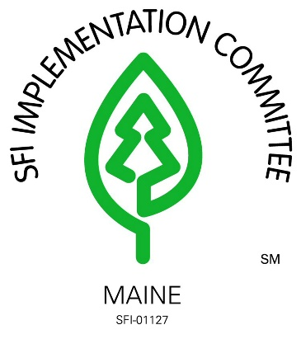

SFI Implementation Committee Coordinator Search

September 2024

**Organization’s purpose**

The SFI Implementation Committee (SIC) is an independent, private, nonprofit organization established exclusively for charitable and educational purposes including engaging in outreach and educational programs to increase public awareness and understanding of the Sustainable Forestry Initiative (SFI) and the environmental, social, and economic benefits of sustainable forestry, to increase public awareness and understanding of sustainable forestry practices in Maine, and to assist organizations in Maine in securing and maintaining SFI Certification.

Employment time: full-time

Job title: SFI Implementation Committee (SIC) Coordinator

Qualifications:

* Strong facilitation and committee management skills
* Background in forestry or natural resources required
* Grant writing skills desired
* Willingness to travel statewide with some out of state travel annually
* Familiarity with 3rd party forest certification (SFI preferred)
* Experience in organizing and coordinating training seminars, tours and meetings
* Experience in teaching adults
* Strong written and verbal communication skills
* Ability to establish and maintain a strong social media presence
* Strong financial management skills including budget preparation, analysis, decision making, and reporting
* Willingness to engage and participate in forest sector stakeholder groups

The SIC Coordinator facilitates the implementation of the Sustainable Forestry Initiative (SFI) standards through projects and programs administered by the SFI Implementation Committee.

Responsibilities include:

* Hold quarterly board of directors’ meetings
* Staff subcommittees on outreach, education, conservation, and public accountability
* Promote the Sustainable Forestry Initiative at various events
* Represent the SIC on various boards and committees
* Work with forestry experts to develop natural resource related educational materials
* Work with industry, agency, and conservation partners to deliver training materials to forest practitioners
* Actively pursue new industry organizations interested in achieving SFI certification
* Maintain a strong comprehension of the SFI Certification Standards
* Work with contract accounting services to establish budgets and manage finances
* Produce annual progress reports for submission to SFI Inc.
* Avoid the appearance that organizations not currently certified to the SFI Standard are in conformance with the SFI Standard.
* Engage with partners or supporters, including students and young people, who share SFI’s mission of advancing sustainability through forest-focused collaboration

Compensation will be commensurate with experience.

Benefits package includes:

* Health Insurance
* Dental Insurance
* Retirement plan with match
* Company vehicle provided
* Paid vacation, sick leave, and holidays

The Maine SFI Implementation Committees’ offices are located in Augusta, ME. This is a full-time, permanent position. For the successful candidate, the board may entertain a flexible schedule and remote working arrangements. To apply, please send a cover letter, resume, and references to [psirois@maineforest.org](mailto:psirois@maineforest.org).

Applications are due by October 25th, 2024. Candidates will be interviewed in November with anticipated hiring timeframe of mid-December.